Objectives:

* If Structures

**Complete the following projects below. There are 3 projects, each worth 33.3%.**

**Project #1**

**#1 print screen the running application with output and code below here.**

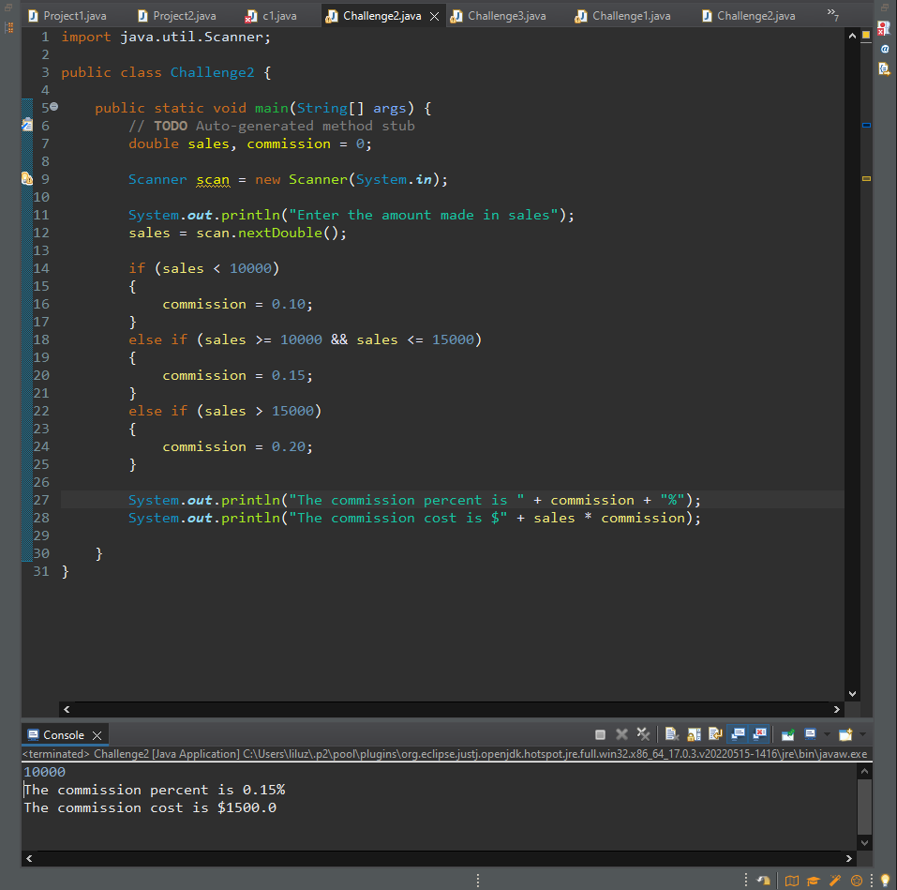

**Project #2**

**#2 print screen the running application with output and code below here.**

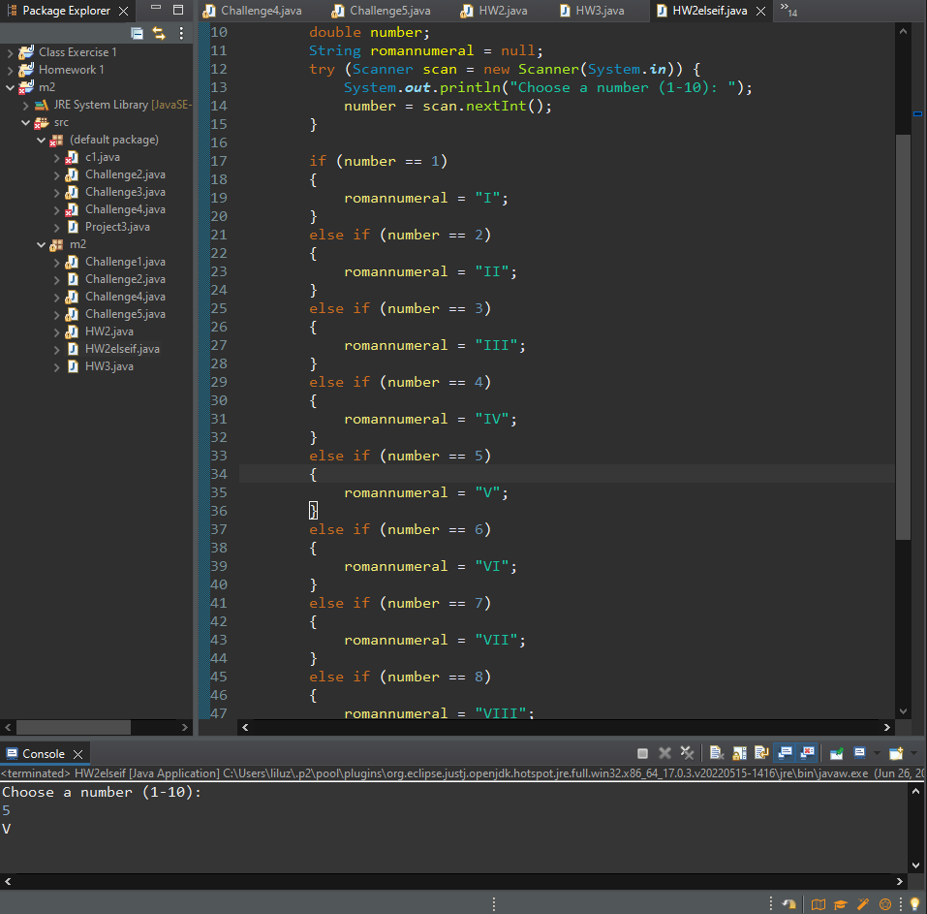

**Project #3**

**#3 print screen the running application with output and code below here.**

**Submit this document to Module 2 homework.**

